Slop Recipe by 1C

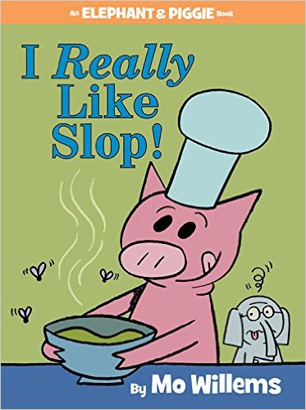
Ingredients:

Stinky socks
Garbage
Snot
Crusty toothbrush
Armpit hair
Fish bones
Frog
26 boogers
Dead quail
Dirty underwear
Acid
Frog
4 mouldy mice
Guts
Mud
Eraser
Stinky bin
13 rotten eggs
Dead red back spider
Cow
Mouldy books
Jar of farts
15 rotten packets of cheese
Mouldy meat

Stir carefully and leave for 7 days - enjoy!

